Dot Painting Animal  - Create a picture of an Australian animal (e.g. kangaroo, turtle, snake).  - Use dots only (finger paint, cotton buds, or paper dots).  - Think about using earth colours (red, yellow, brown, black)  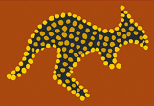 | Story Symbols Drawing  - Draw a simple picture that tells a story (e.g. going to the park or walking with family).  - Add simple symbols (circles, lines, tracks) to show people or paths.  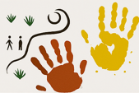
Handprint Art  - Decorate handprints with dots or lines.  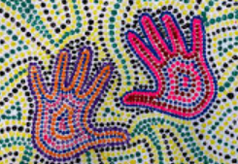 | Bush Landscape Collage  - Create a landscape using coloured paper, leaves, or drawing.  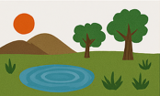  - Include things like sun, waterholes, trees, and animals.
Pattern Music Art  - Listen to music (drumming or nature sounds).  - Make patterns (dots, lines, shapes) that match the rhythm you hear.  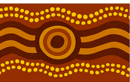 | Animal Tracks Pattern  - Draw or paint repeating animal track patterns across a page.  - You can invent your own tracks or copy simple ones like bird or kangaroo prints.  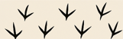
Summer 2 Year 1 Topic (Art based) Homework Project

