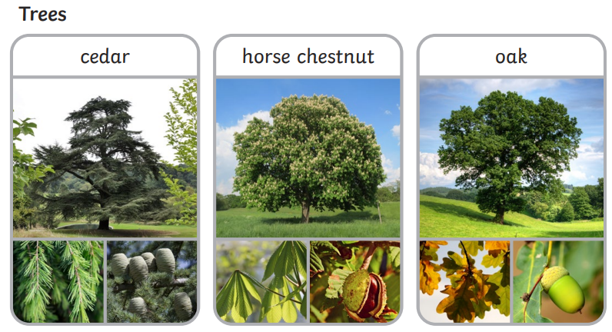
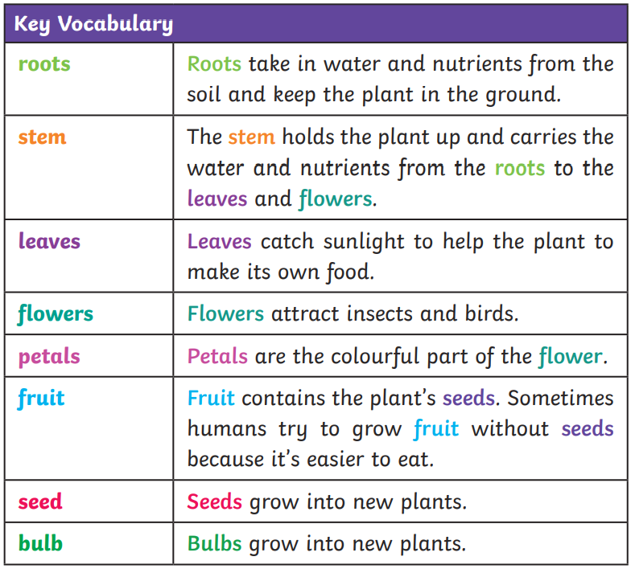
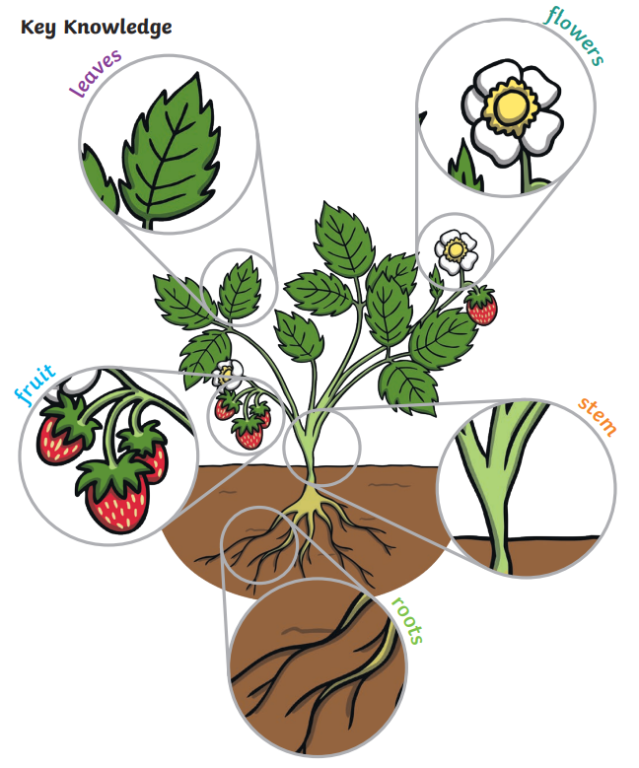
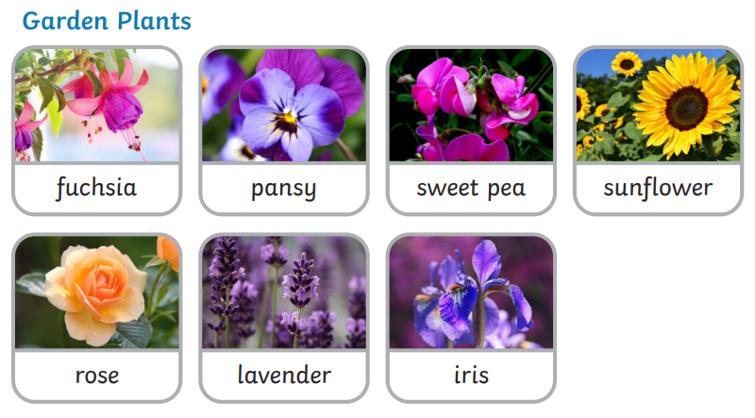
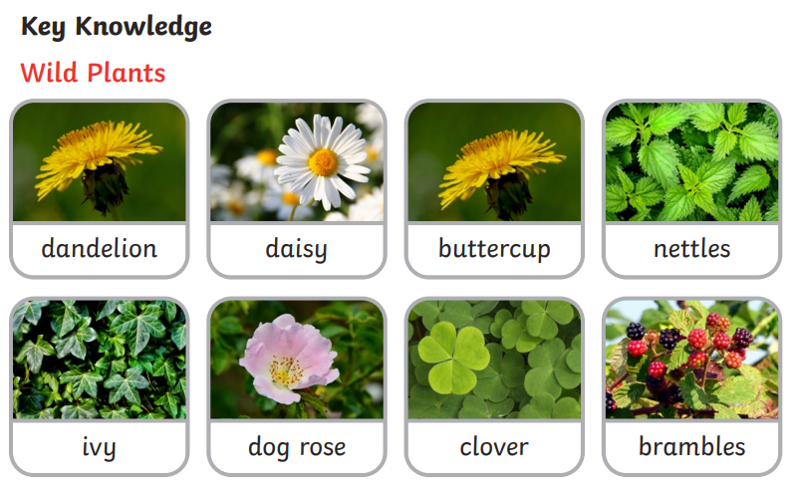
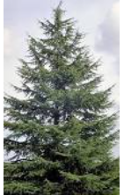
Plants need…
Some trees are evergreen, which means that they keep their leaves all year round. Eg: fir, pine.
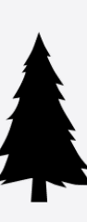 Some trees are deciduous, which means that they lose their leaves when it gets colder in the autumn. E.g.: oak, horse chestnut. 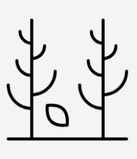

Plants have common parts, but these can very between different types of plant.

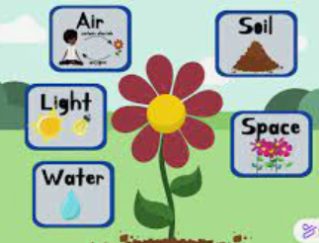

What do I already know? The children have learned about similarities and differences between living things. They can talk about features of our immediate environment and about how environments might differ from one another. They have looked at plants and animals and observed how they change.
SUMMER 2 2026 YEAR 1: GREEN PLANTS The Big Idea: What plants are there in the local area and what are they like?

