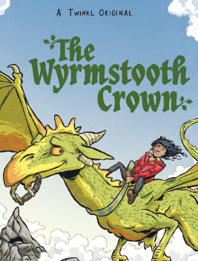

This story is a fantastic ‘legend’ written by Twinkl and is perfect for Year Three to really get their teeth into! The text is age related but will challenge them so adult support in ensuring understanding is key. The tasks are organised in a way to ensure that the children fully understand the events of the first chapter, before moving onto anything more in depth.
Please complete all the tasks either in the English books that were sent home in their original packs or on lined/plain paper.
Hopefully the children will want to continue reading the rest of the story once the project is complete! As always, if you have any questions or queries, please contact me on apple-teachers@crossdale.notts.sch.uk.

Task 1
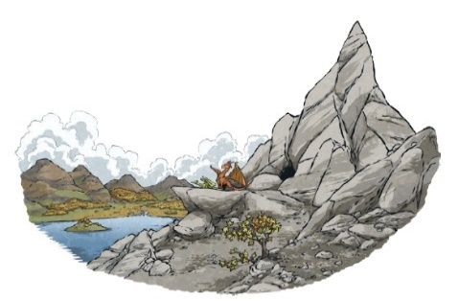
- Read the first chapter and then re-read for speed and understanding.

- Check any words that you are unsure of with a grown up or using a dictionary. Write three of these words down and include your own definition.

- Write 4-5 sentence summary to show the key events in the chapter.
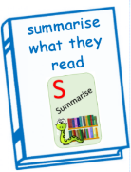
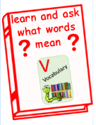

_________________________________________________________________
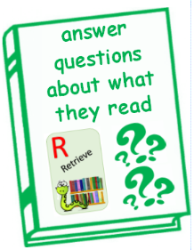
Task 2
- Re-read the first chapter again for speed and understanding if you think you might have forgotten the key events.

- Use your R (retrieve) VIPERS to answer the following questions. Remember that with retrieval you should get the answer directly from the text – you could even highlight it on the computer if possible.

Who is the main character of the story? (pg 1)
What is type of character is he? Human? Dog? Alien? (pg 1)
Why was Guster itchy? (pg 1)
Why did his scales need to change colour? (pg 1)
Why did Guster go into the lake? (pg 2/3)
What did Guster spot on the far side of the lake? (pg 3)
What were Guster’s favourite stories? (pg 4)
What gift does Redbreath have? (pg 5)
What have the humans done to the dragons for thousands of years? (pg 6)
What was the name of the clan chief and dragon queen that lived together peacefully over thousands of years ago? (pg7)
How did the humans and dragons first know of the barbarian attack? (pg 8)
What made the barbarians flee and leave? (pg 12)
What did the humans make to celebrate the human and dragon victory of the barbarians? (pg 12)
Why are the humans and dragons at war even though they had worked together in the past? (pg 12)
_________________________________________________________________
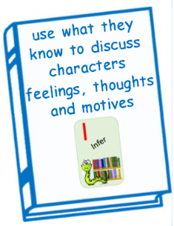
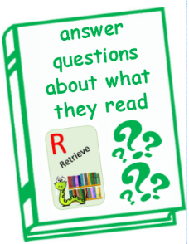
Task 3

- Re-read the first chapter again for speed and understanding if you think you might have forgotten the key events.
- This task is all about retrieving and inferring about what you have learnt about Guster
What have we learnt about Guster so far? How would you describe him? What is he like as a character? Draw a picture of Guster and around him retrieve words and phrases from the text that paint of picture of what he looks like and what he is like as a character. Not all of this will be obvious, you might have to use your inference skills too (what can we guess about the thoughts and feelings about a character using what we have read, even though we haven’t been told.)
For example… ‘green summer scales’ help paint a picture of what he looks like and ‘Guster thought humans must be very stupid’ tells us about what he is like as a character… rude/thinks he is clever. (inference)

_________________________________________________________________

Task 4
- This task is structured like a VIPERS session that you would have had at school.
- Read pages 3-5 and then answer the ‘everyone challenge’ – do you agree with it, build on it or challenge it.
- Next choose one of the ‘S’ challenges – you could even complete them all if you were feeling super whizzy!
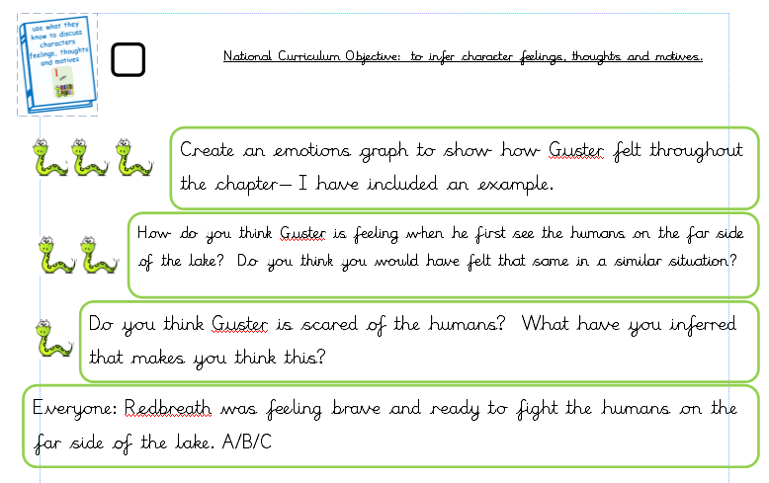
Example emotions graph – remember to include the specific events and for a challenge, label the specific emotion – ecstatic, down-heartened, petrified
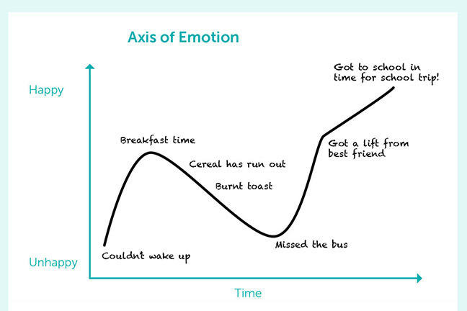

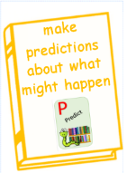
_________________________________________________________________Task 5
- For your last text of the project, I would like you to write a prediction that shares what you think is going to happen next in the story.
What will the problem be? Can you include character feelings and emotions and lots of detail of events?
What will the resolution be? Will it be easy? Will something go wrong? How can you make the reader want to read on?
How will the story end? How will the characters be feeling? What lesson will they have learnt? What is next for them? Cliff hanger?

Read the rest of the story

