Slime is an interesting substance to make because it uses different ingredients to create something new and fun! In this instruction card there are several different types of slime that you can make. At the science fair we will compare our different slimes and see if we can find a difference between them. We are looking forward to seeing your creations!
Crossdale Science Fair 2018
Home Science Project
Making slime
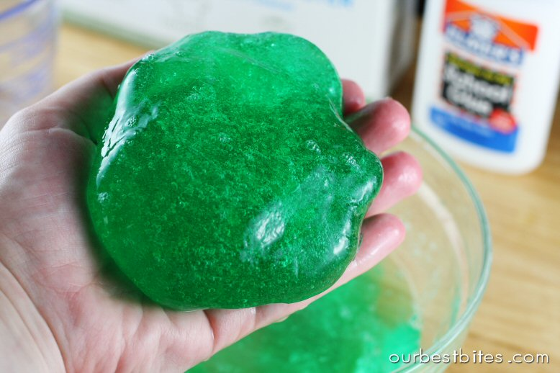
SIMPLE SLIME

Equipment
· Cornflour
· Water
· Food colouring (optional)
· Mixing bowl
· Spoons (optional)

Method
- Put approx ½ cup cornflour in the mixing bowl then add ¼ cup water.
- Mix, add a few drops of colouring.
- When blended ( or even before) get your hands in there and experience the odd properties of your slime. How can it be squeezed into a solid then turn back into liquid when you open your hands? Did you know you have created a Non-Newtonian Fluid?
SUPER SLIME A drier but firmer slime

Equipment
· Cornflour
· White pva glue (use the children’s washable stuff.)
· Food colour
· Mixing bowl
· Wooden spoon
· Something to store your slime in (sandwich bag?) as it’s going to dry out quickly.

Method
- Put ½ cup of the PVA into the bowl.
- Put a few drops of food colouring into the glue
- Gradually add the cornflour, stirring the mixture as you go. Too much cornflour makes a really dry mix so go easy when you’re pouring it in!
- Get your hands into the mix - if you haven’t already - and watch it flow between your fingers. Roll it and stretch it.
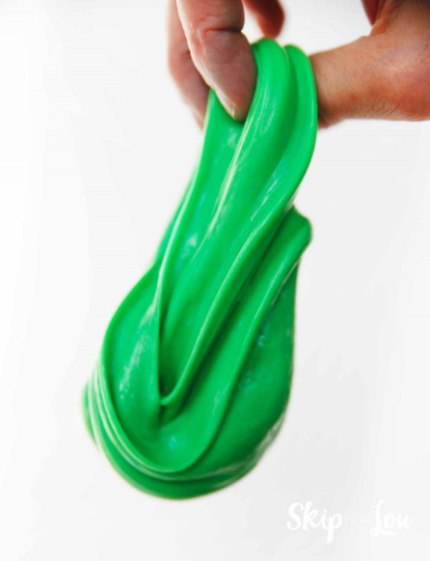
BOUNCY SLIME A little more complex

Equipment
· Cornflour
· White pva glue (use the children’s washable stuff.)
· Cold water
· Liquid starch (or mix dry laundry starch with water)
· Food colour
· Mixing bowl
· Wooden spoon

Method
- Mix ½ table spoon of liquid starch with ½ tablespoon water in a mixing bowl
- Add 1 tablespoon of white glue to the mixture.
- Mix well for 1 minute.
- Add another tablespoon of white glue to the mixture. Mix well for another minute.
- Let the mixture stand for several minutes to thicken.
- Pick it up in your hands and roll it about to get the stickiness off and allow it to dry off.
- Now you can try stretching and bouncing it!
Possible extensions
- Comparing different types of slimes – what is the same? What is different?
- Rolling slime on newspaper – what happens to the slime?

