Engineers - Home Learning Map – Reception – Week Beginning 22/06/20
Remember that English, maths and wellbeing skills should take priority but also just do what you can and stay safe!
Reading  Read every day for 15 minutes.  This can be a combination of you reading and also listening to or sharing books with others.  To listen to this week’s stories, go to:  (this week’s core book audio story)  https://classroom.thenational.academy/schedule-by-year/reception (Tuesday’s lesson)  Oxford Owl’s Free e-book library https://www.oxfordowl.co.uk/for-home/find-a-book/library-page/  NEW ‘Story a day’ from the Keydale staff on the school reading blog.  Tricky Tracker Words  Review the words you know. Can you display your current tricky tracker words so you can use them when writing. | Writing  This week’s writing is based on the topic of engineering. We are going to be thinking about making something to solve a problem eg. A comfy, safe bed for a pet mouse.  https://classroom.thenational.academy/schedule-by-year/reception (on Oak Academy website click on ‘Schedule’, choose Reception and click on week 8 English lessons)  Challenge  Can you draw a picture of what you want to make? Can you label the different parts of the picture or maybe write a list of the things you will need to make it? | Understanding the World  Can you find out about a famous inventor or engineer?  What is their name?  What did they invent or make?  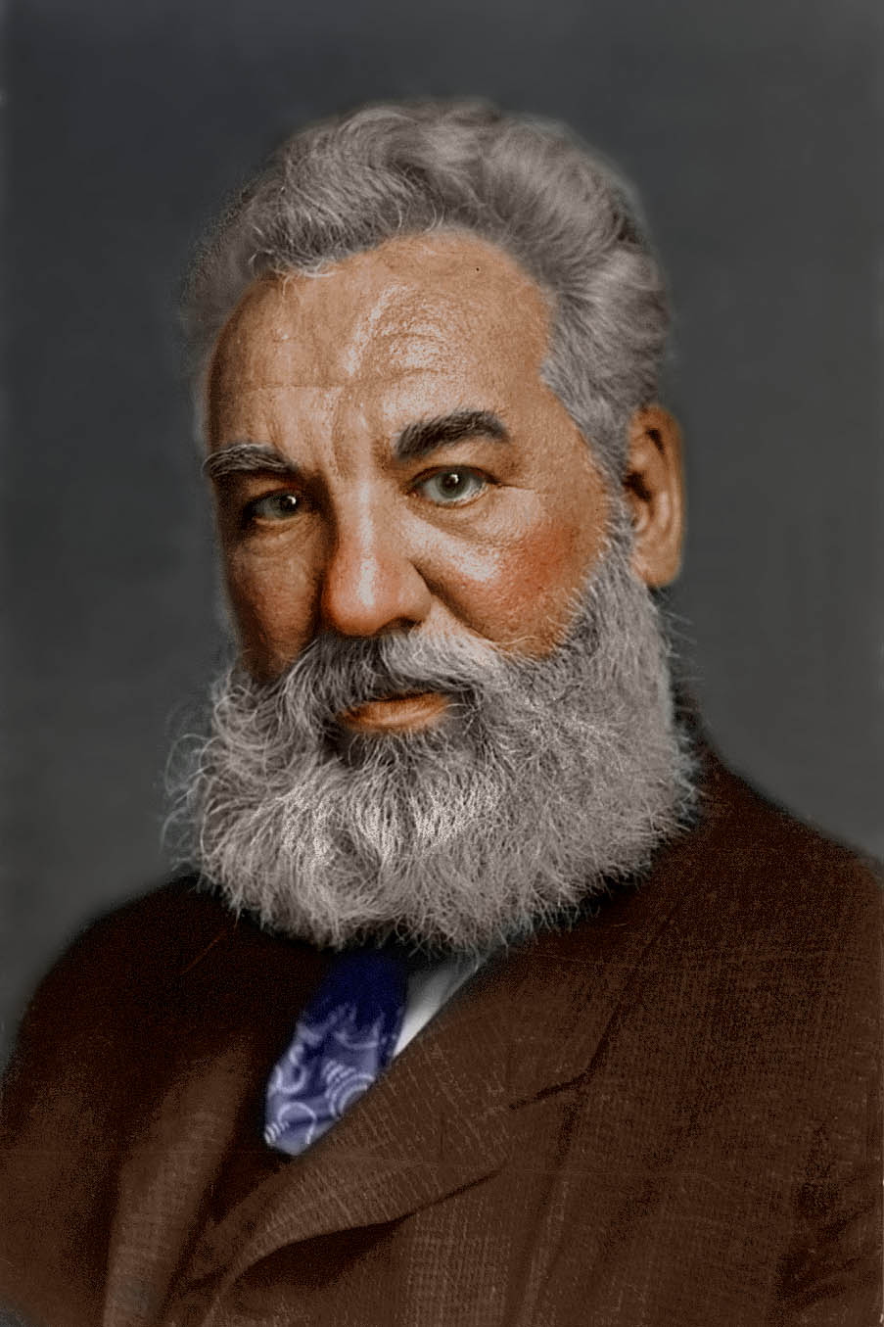
Maths  - Oak Academy maths lessons week 8 (1 a day)  (On Oak Academy website click on ‘Schedule’, choose Reception and click on week 7 Maths lessons)  https://classroom.thenational.academy/schedule-by-year/reception/  This week’s focus is addition and subtraction. | Physical Complete 3 workouts.  - Bike ride / scoot  - Run/walk  - Cosmic Yoga (You Tube)  - Zumba kids -Minions Zumba (You tub) | Phonics  Complete at least 3 Read, Write Inc. phonics sessions on You Tube: (12 mins)  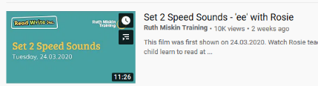  Set 1 Speed Sounds with Rosie or  Set 2 Speed Sounds with Rosie  Reading Eggs Compete at least 3 activities
Community  Can you do a job around the house that will put a smile your grown-ups face! You could make your bed, tidy your toys, put your shoes away..... | Wellbeing  Can you choose a song and play a song you like to listen to it. How does it make you feel? | Get Creative  Use your drawing skills to design your own design of what you would like to make.

