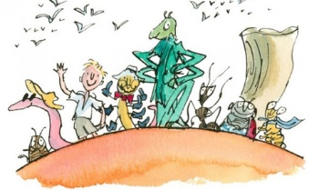
Chapter 10 – 11: Comprehension ANSWERS
Page 37
1. The hole in the peach is large enough for which animal? Tick one
A fox
A lion
An elephant
2. Find and copy a phrase or sentence that describes what it is like inside the tunnel.
Accept any of the following
- damp and murky
- there was a curious bittersweet smell of fresh peach
- the floor was soggy
- wet and sticky
- juice was dripping from the ceiling
Page 38
3. Number these events to show the order they happen
The door swung open
4
1
The top of James’ head bumped into something
He gave a push
5
3
He crawled through the door
2
He touched the stone with his fingers
Page 39
4. Read the last part of chapter 10 on page 39. How do you think James is feeling? Why do you think this? Support your answer using evidence from the text.
I think James is feeling scared (or similar). Accept answers that use appropriate evidence from p39 e.g. his face white with horror, his knees were shaking, thinking he could bolt back into the tunnel.
Page 39-40
5. Match each creature with the correct adjective or description
Grasshopper scarlet
Spider thick and white
Ladybird as large as a large dog
Centipede enormous
Silkworm reclining comfortably
Page 41
6. Find and copy a word that means ‘hungry’
famished
Page 42
7. How does the author suggest the spider might want to eat James?
Accept any answers referring to the spider opening her mouth or running her tongue over her lips
8. Why did the creatures all roar with laughter? Tick one
They thought James looked funny
The centipede was telling funny jokes
They realised James thought they wanted to eat him
Page 43
9. When talking about his boots, the centipede says, ‘It takes me hours to get them all off by myself.’ Why do you think this is?
Centipedes have lots of legs so it would take a long time

