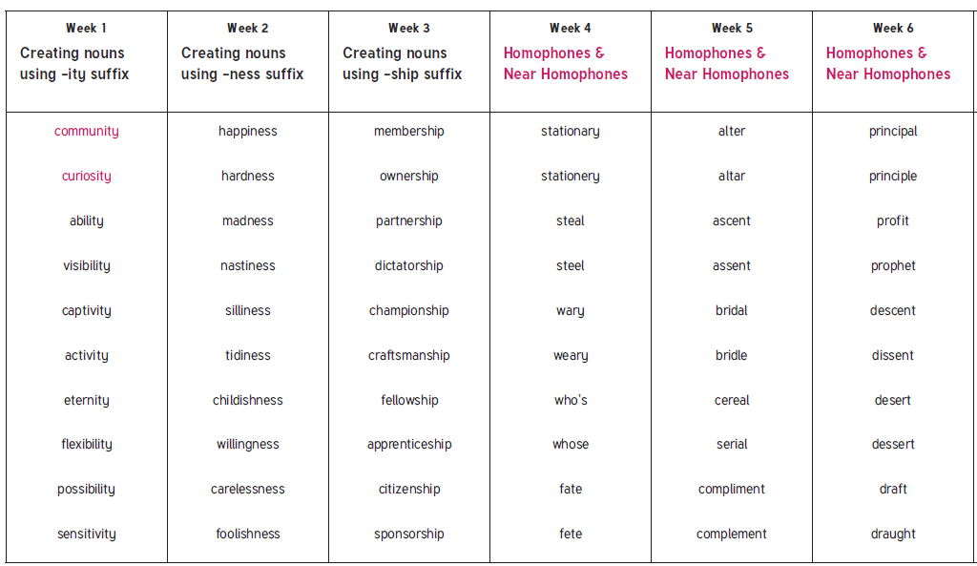
Year 5 Spring Term 1 spellings

