**What kinds of animals are there?**

There are many different types of animals and they can be put into groups according to their features, eg:

**What is a food chain?**

A food chain shows us how living things get food.

All food chains begin with a plant, eg:

*Herbivore;* an animal that eats plants

*Carnivore*: an animal that eats other animals

*Omnivore:* animal that eats both plants and other animals

**AMAZING ANIMALS!**

**The Big Idea: What kinds of animals are there and how do they live?**

All living things have offspring that grow and change. This is called a ***lifecycle.***

**The lifecycle of a chicken**

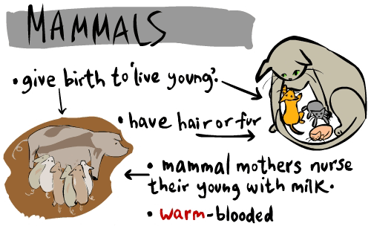

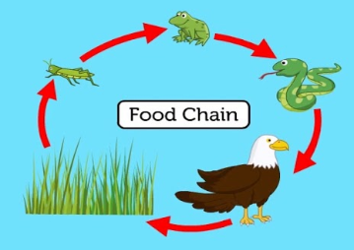

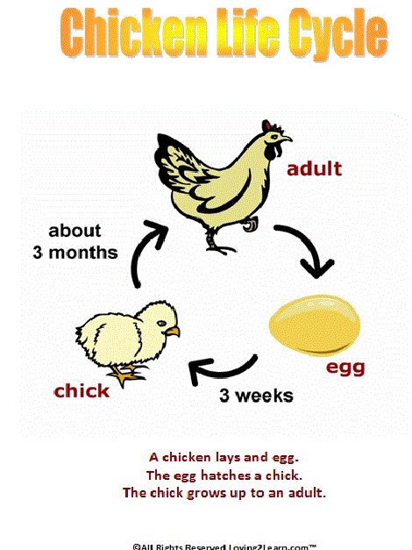

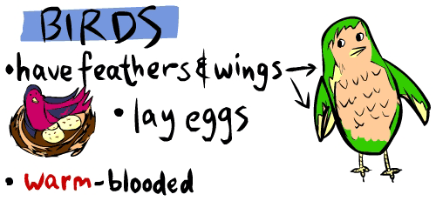

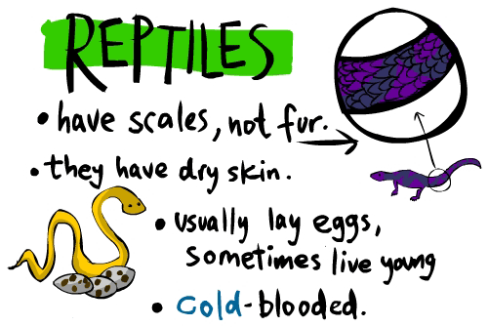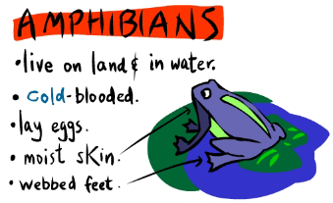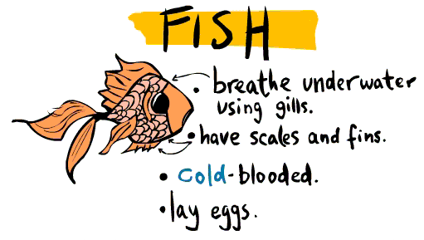

.

**What is a habitat?**

**A habitat is where an animal lives. It provides everything the animal needs to survive:**

**shelter - food - water**

**There are many different habitats eg**

**desert - forest - pond - tree - ocean**

All animals have **features** that make them suited to their habitat eg teeth shaped to eat either meat or plants

An example of how an animal is suited to its habitat:

