Crossdale Lunchtime Challenge
Week 1- How long can you hula-hoop for?
Monday | Tuesday | Wednesday | Thursday | Friday
Niamh Spencer, Alice Kysela, Holly White, Ava Clarke | Millie Clements, Clara Sharman, Aiqi Freeman, Amelia Clarke | Mitchell Meakin, William Harper, Finlay Burman, Joe Sleeman | Rebeccas Clay, William Bee, Dakota, Shakya | Charlie Pride, Hugo BR, Joe Coxon, Kai Hathway
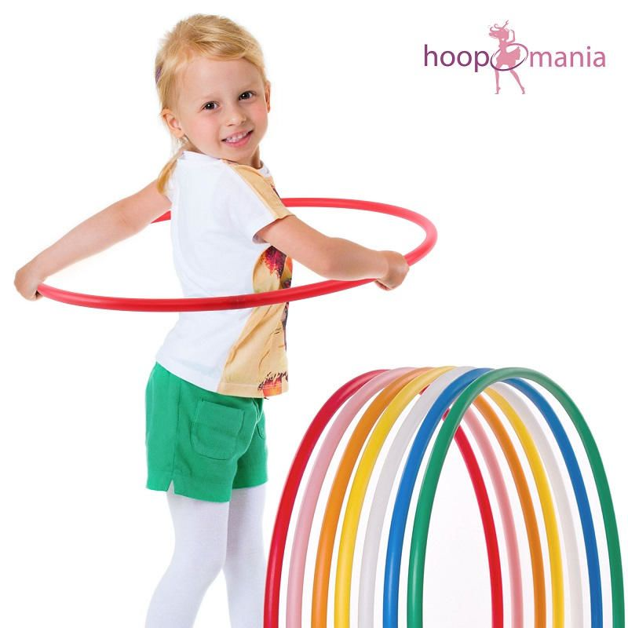
How long can you hula-hoop for?
You must start with the hoop around your waist. As soon as you are ‘ hula-ing’ you must keep the hoop off of the floor for as long as possible without it touching the floor. The time will start when you first let go of the hoop and will stop when it hits the floor. Good Luck!
Prize for the winner of each Base.

