Tricky Tracker 5
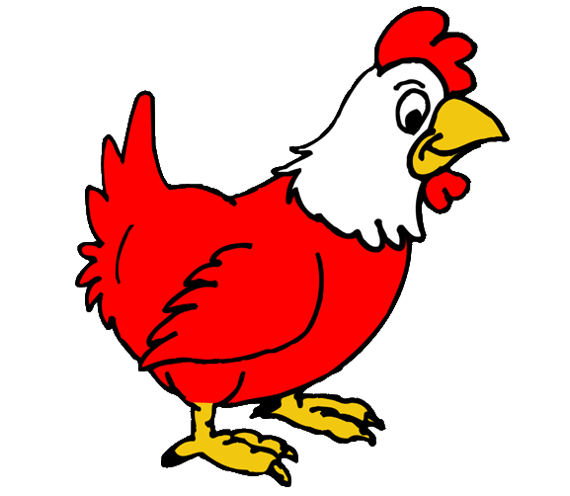
be was her have like so do
start | be | was | her | have | like | so
do | like | her | so | was | have | do
be | have | do | her | like | was | so
so | do | be | was | her | like | like
her | have | was | like | be | have | be
so | her | like | have | do | was

