Beegu by Alexis Deacon - Home Learning Map – Reception – Week Beginning 06/07/20
Remember that English, maths and wellbeing skills should take priority but also just do what you can and stay safe!
Reading  Read every day for 15 minutes.  This can be a combination of you reading and also listening to or sharing books with others.  To listen to this week’s story (Beegu) go to:  https://classroom.thenational.academy/schedule-by-year/reception (Week 10 Tuesday’s lesson)  Oxford Owl’s Free e-book library https://www.oxfordowl.co.uk/for-home/find-a-book/library-page/  Tricky Tracker Words  Review the words you know. Can you display your current tricky tracker words so you can use them when writing? | Writing  This week’s writing is based on the book Beegu, by Alexis Deacon,  https://classroom.thenational.academy/schedule-by-year/reception (on Oak Academy website click on ‘Schedule’, choose Reception and click on week 10 English lessons)  Super sentence: Do you need help?  Challenge:  Can you write a letter to Beegu? What would you say to him to make him feel welcome? | Understanding the World  Can you find out what happens to the letters we post?  How does it get to their intended recipient?  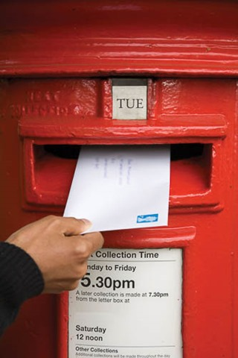
Maths  • This weeks maths lessons are based on the book Oliver’s Vegetables by Vivian French which can be found at ….  https://whiterosemaths.com/homelearning/early-years/  There is a short lesson every day which is followed up with a variety of different activities.  This week’s maths themes are patterns, counting accurately to 20, ordering numbers to 20, addition and subtraction and halving and doubling. | Physical  Complete 3 workouts.  - Bike ride / scoot  - Run/walk  - Cosmic Yoga (You Tube)  - Zumba kids -Minions Zumba (You tub) | Phonics  Complete at least 3 Read, Write Inc. phonics sessions on You Tube: (12 mins)  Set 1 Speed Sounds with Rosie or  Set 2 Speed Sounds with Rosie  Reading Eggs Compete at least 3 activities
Community  Can you write a letter to someone you care about and send it in the post to them? | Wellbeing  What could you do to be kind to a lonely person?  Can you think about the ways people have been kind to you? Can you thank them for it? | Get Creative  Make a Beegu puppet and take him on an adventure!  Design and make a friend for Beegu (use junk modelling),  Design some cards/pictures to give to people you care about.  Build a space station or a spaceship for Beegu to travel home in.