Homework for week beginning 25.11.19, Test on 2.12.19

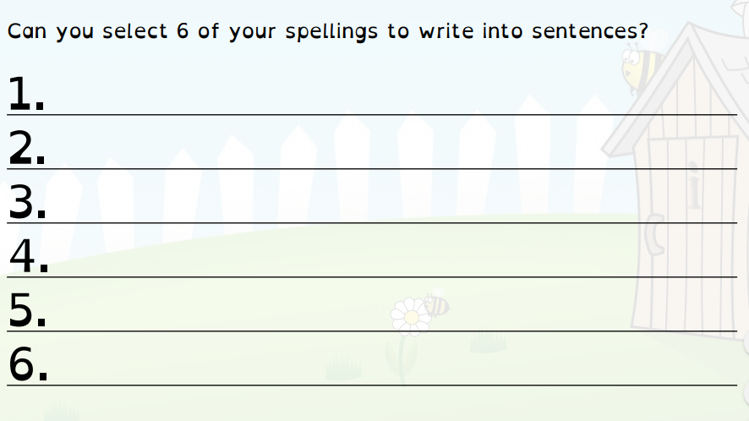
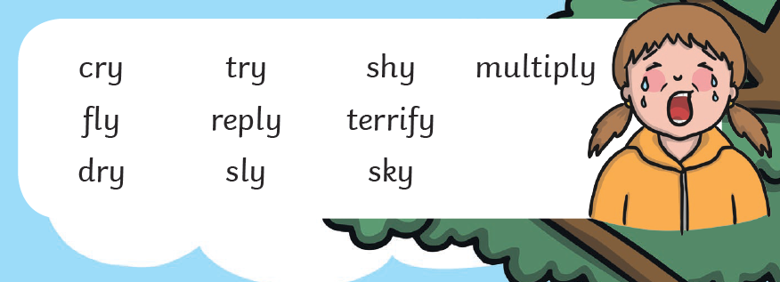
Tell someone at home what these 10 words mean.
What is the spelling rule that connects this word?

