The Immunisation Team will shortly be visiting school to deliver the flu vaccinations:
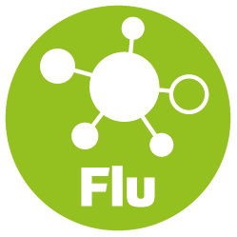
School Name: Crossdale Primary
School Code: NG143300
Visit Date: 2nd December 2021
Please complete the electronic consent form at:
www.nottinghamshireimmunisations.co.uk
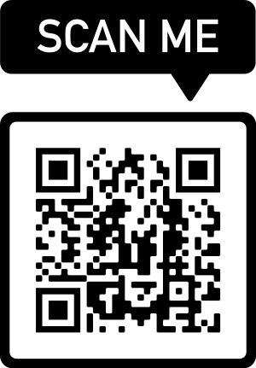

If you require any further support do not hesitate in contacting us at Tel: 07920182032 Email: SAIS@nottshc.nhs.uk

