Welcome Back

Reception Curriculum Map
  - Summer One

We hope you’ve all had a lovely Easter break and are looking forward to an action packed half term.
The following Curriculum Map aims to give you a snap shot of our planning for the weeks ahead. Please continue to check the Reception Blog as we will still share information and photos.
As we enter the Summer term, things will be getting a little more formal to prepare the children for transition to year 1. They will still have time to follow their own interests and extend their thinking and we plan to make it as fun and engaging as ever!

Reading
In the aim to get children to an ‘expected’ level which is to be confidently reading red colour book banded books, we will be having a big focus on reading.

Children will continue to have a combination of individual, group and class reading opportunities throughout the week. The children will change their ‘Swap’ and ‘Colour’ books on a Friday.

We are always looking for extra adults to read with children --even 20 minutes at the beginning or end of the day would be a huge help.

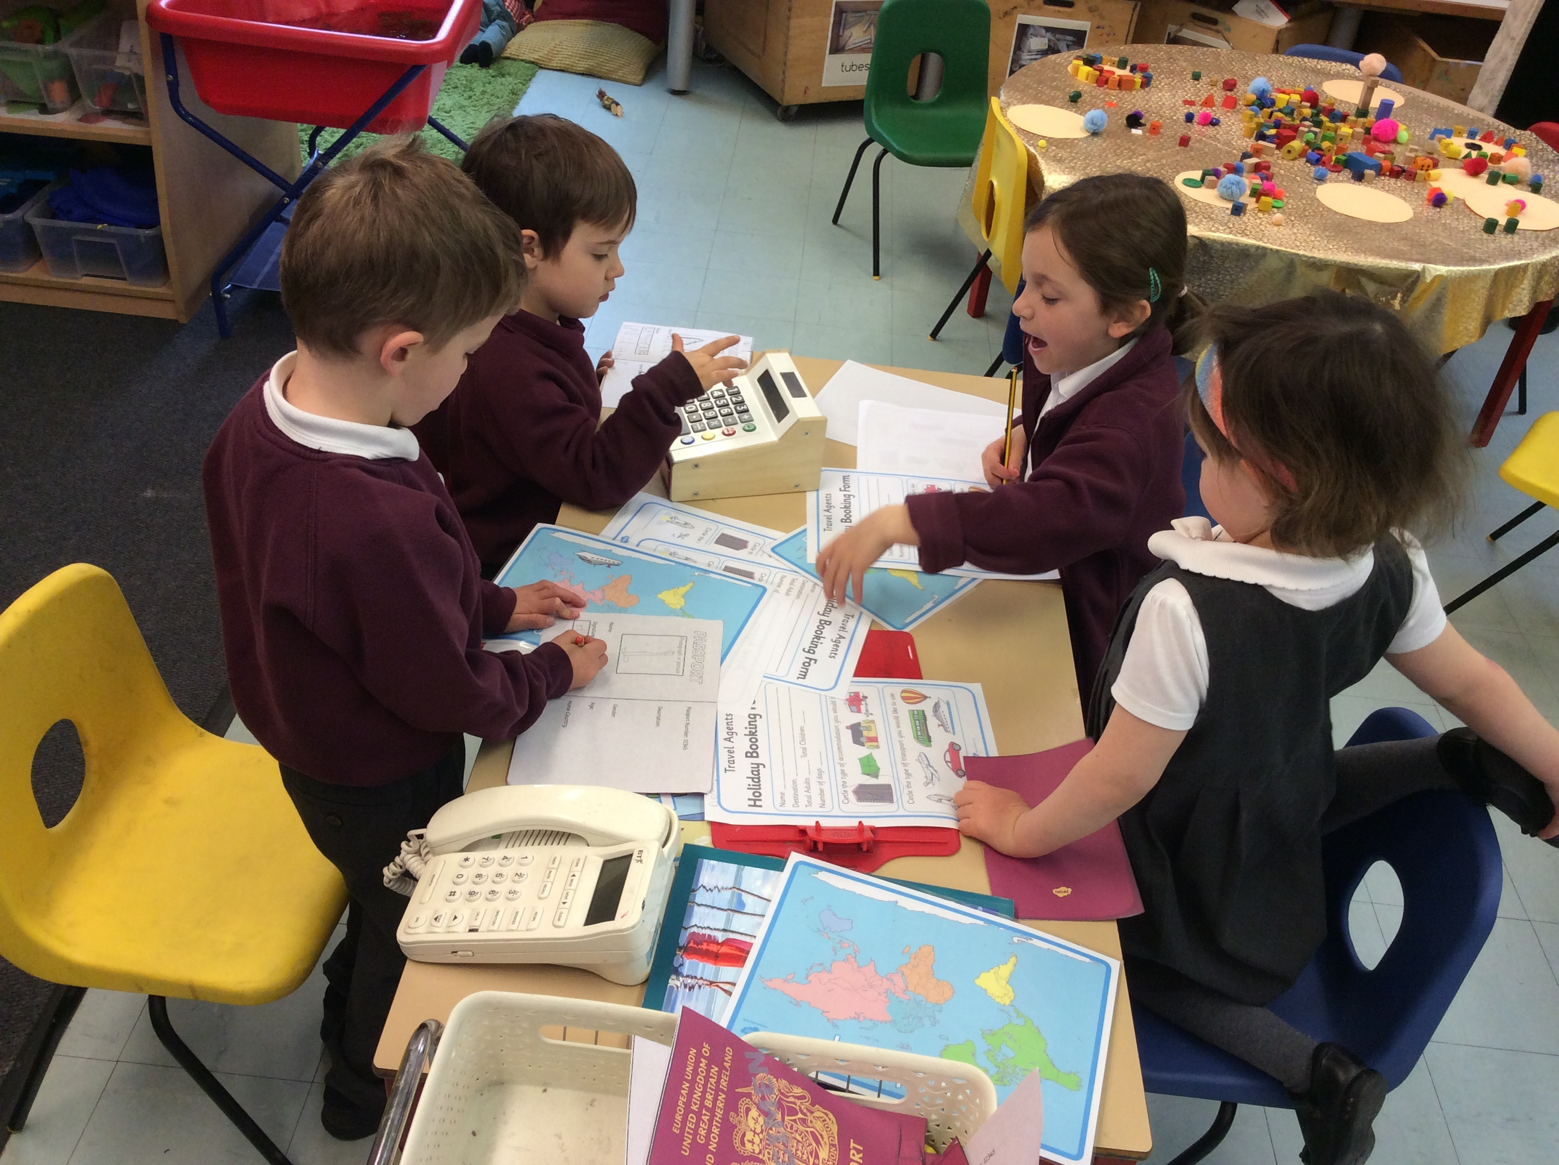 |  | Writing  We will be starting a weekly news writing books this term. As well as using all of their writing skills they will get to practice composing their own sentences. Please keep a look out for any writing that comes home in your child’s book bag. This will inform you of their current level of writing and their next steps.
Maths  Our focus this half term will be using and securing numbers to 20, halving, doubling and sharing quantities and numbers. This will be taught in our daily, active, maths sessions. This will be followed by lots of opportunities to apply their learning in problem solving activities. |  | 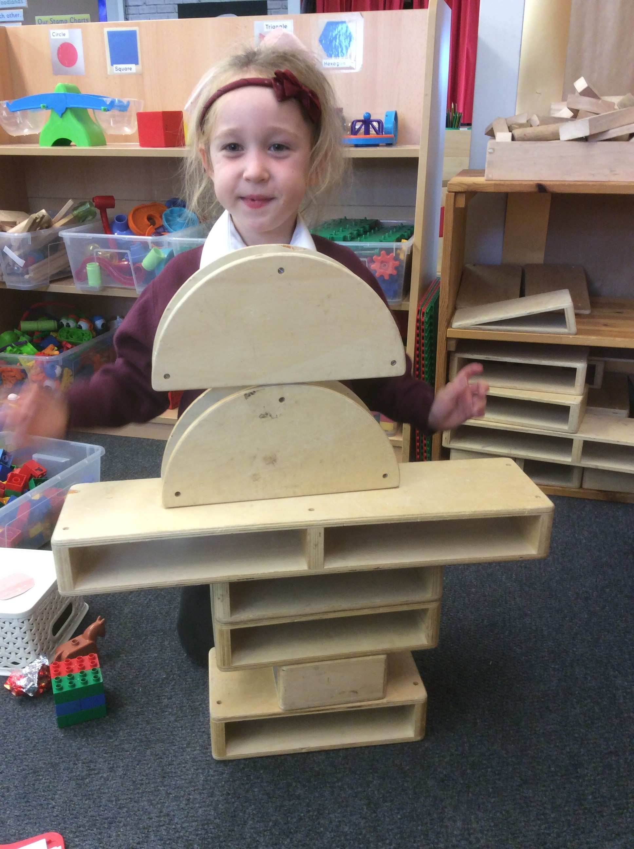

Book of the Week
We will launch each week with a new focus book which links into our topic question. We use the focus book to base a daily comprehension activity on as well as sparking ideas for the children’s own interests. The books are as follows –
Week 1 Jack and the Beanstalk (we like to start with a Traditional Tale)
Week 2 Unplugged by Steve Antony

Week 3 Chicken Clicking By Jeanne Willis

Week 4 No-Bot By Sue Hendra

Week 5 Room on the Broom by Julia Donaldson

Topic Question – Can I switch it on?  Can we switch it on? How does it work? These are a few of the questions we will be exploring in this topic about technology in the home and at school, and communication.  Our curriculum consists of 7 areas which we plan specific activities as well as experiences in the environment for the children to explore. Here are a few that we intend to introduce to the children this half term.  Communication and Language  Making a short video using a tablet showing and telling a visitor their favorite part of the classroom.  Understanding the World  Explore ‘then and now’ by providing the children with a variety of pictures/items that show how technology has changed everyday activities such as cooking, cleaning and communicating.  Mathematics  Use the Bee- Bots (floor robots) to explore different directions and estimate distances.  A Few Extra Bits……  Design a Robot  We have planned a robot DT afternoon for the 15th May. If you would like to join us for an afternoon of making please let us know. Please start collecting any interesting junk materials for the day.  Day Swaps  This half term Mrs Ingle will be in for the first full week and Mrs Mellor will be in for the week beginning 6th May. Apart from that it’s business as usual.  Communication  As always, we really appreciate your support in all the many areas of your child’s life. Any problems or worries please pop in and see us or send a message to everylittlevoicematters@crossdale.notts.sch.uk  Please use this for any achievements, happy moments and photos.  Mrs Mellor and Mrs Ingle |  | 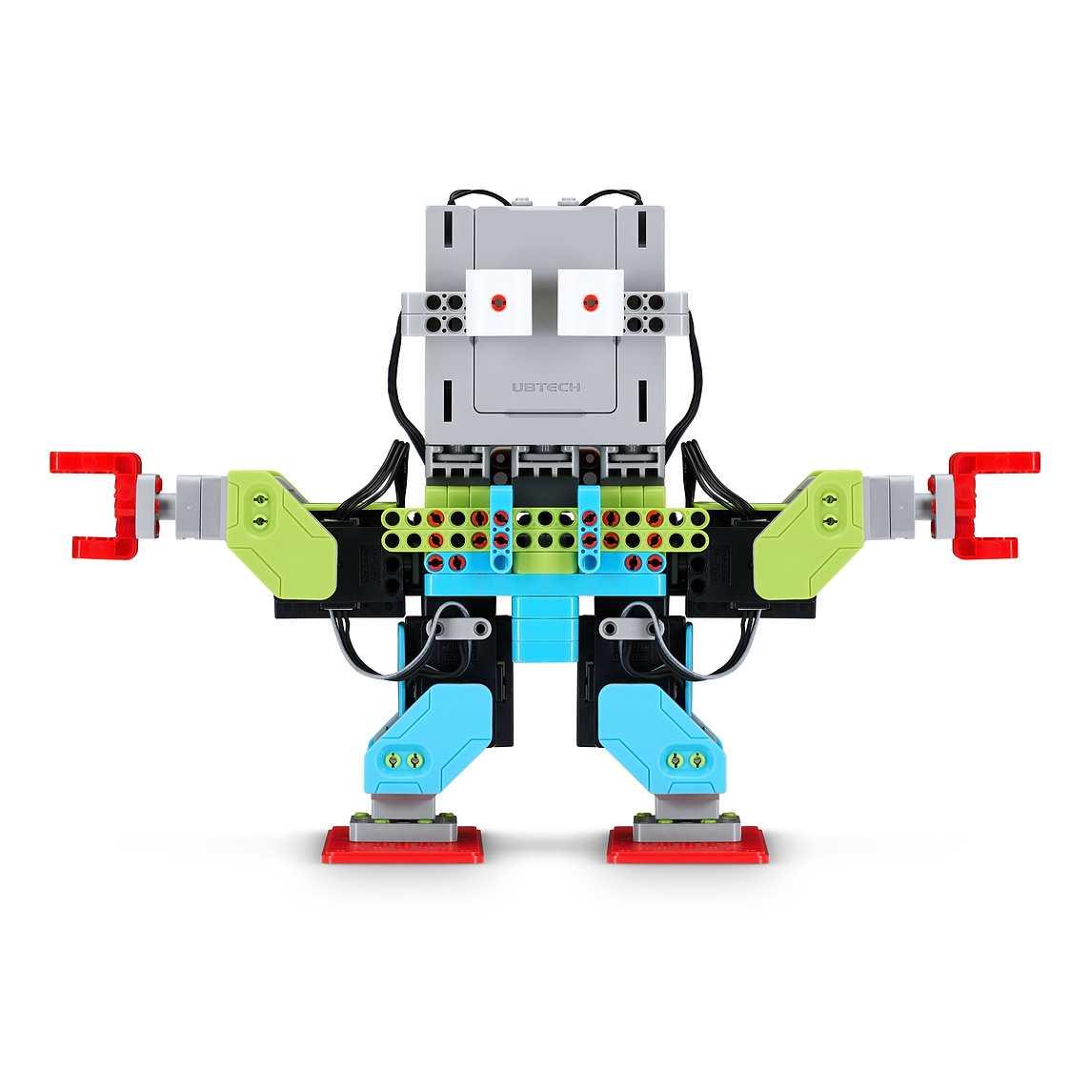  Expressive Arts and Design  Use a range of cogs, wheels, buttons, wires, and switches to make patterns and shapes.  Personal, Social and Emotional Development  Show the children the photocopier and talk about what it does. Use it to make some photocopier art to display in the classroom.  Physical Development  Photograph/video children running, jumping, kicking, throwing... Use the clips and photos to discuss the children skills and what their bodies do during exercise.  Literacy  Compose an email together and send to KPNS Reception class. What questions could we ask? Ask for a reply and read it together when it arrives.

